**SDN IP BGP ONOS Docummentation:**

**Topology:**

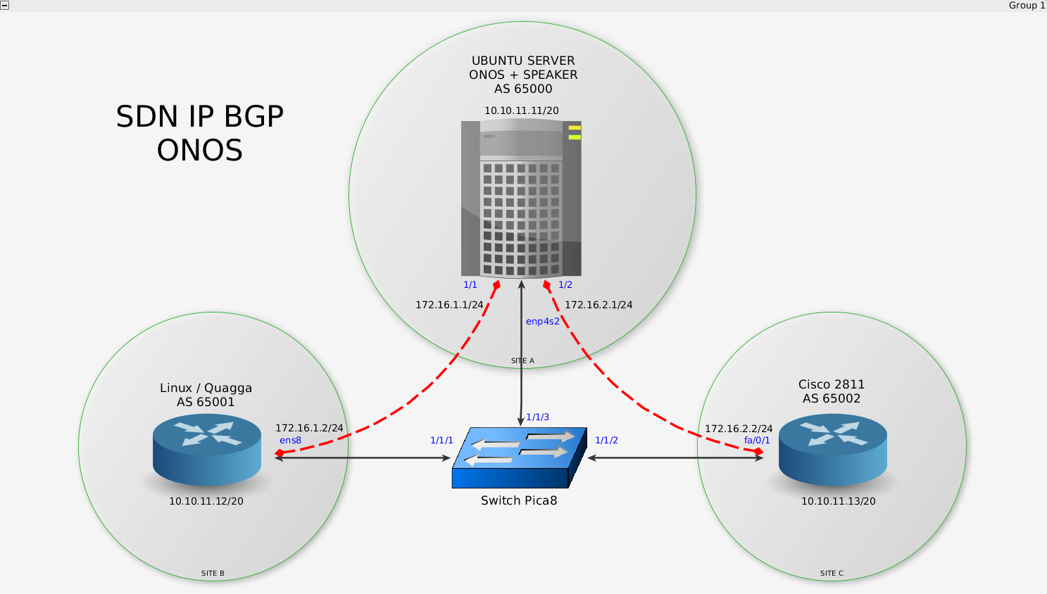

**Devices:**

1. PC Server with OS Ubuntu Server 16.04 LTS ( ONOS Controller + Speaker installed)

2. Linux Quagga Router

3. Cisco Router 2811

4. Pica8 Switch

**Technical Allocation:**

|  |  |  |  |  |
| --- | --- | --- | --- | --- |
| No | Device | Interface | IP address | AS number |
| 1 | PC Server (ONOS+Speaker) | Management | 10.10.11.11/20 |  |
| Enp4s2.1 | 172.16.1.1/24 | 65000 |
| Enp4s2.2 | 172.16.2.1/24 | 65000 |
| 2 | Linux Quagga Router | Management | 10.10.11.12/20 |  |
| Ens8 | 172.16.1.2/24 | 65001 |
| 3. | Cisco Router 2811 | Management | 10.10.11.13/20 |  |
| Fast Ethernet 0/1 | 172.16.2.2/24 | 65002 |
| 4. | Pica8 Switch | 1/1/1 |  |  |
| 1/1/2 |  |  |
| 1/1/3 |  |  |

**Configuration:**

1. PC Server

- Configure PC Server interface so it can have 2 subinterface in single interface:

ip link set up dev enp4s2

ip link add link enp4s2 dev enp4s2-1 address 00:00:00:00:00:a1 type macvlan

ip link add link enp4s2 dev enp4s2-2 address 00:00:00:00:00:a2 type macvlan

- Configure IP address for each subinterface

ifconfig enp4s2-1 172.16.1.1 netmask 255.255.255.0 up

ifconfig enp4s2-2 172.16.2.1 netmask 255.255.255.0 up

2. PC Server (ONOS)

- Install ONOS controller from (<https://wiki.onosproject.org/display/ONOS/Downloads>)

- Configure ONOS BGP Peering to Speaker Router, Quagga Linux Router, and Cisco Router 2911 (network-cfg.json)

{

"ports" : {

"of:0000000000000001/1" : {

"interfaces" : [

{

"ips" : [ "172.16.1.1/24" ],

"mac" : "52:54:00:ec:4c:59"

},

"of:0000000000000001/2" : {

"interfaces" : [

{

"ips" : [ "172.16.2.1/24" ],

"mac" : "00:14:6a:a3:08:11"

},

"apps" : {

"org.onosproject.router" : {

"bgp" : {

"bgpSpeakers" : [

{

"name" : "speaker1",

"connectPoint" : "of:0000000000000001/3",

"peers" : [

"172.16.1.2",

"172.16.2.2"

3. PC Server (Speaker)

- Install Quagga Router in PC Server as a Speaker Router

- Configure BGP Speaker Router with to peering to ONOS (ASN 65000), Linux Quagga Router (ASN 65001) , and Cisco Router 2811 (ASN 65002)

router bgp 65000

bgp router-id 10.10.11.11

timers bgp 3 9

! ONOS SDN IP

neighbor 127.0.0.1 remote-as 65000

neighbor 127.0.0.1 port 2000

neighbor 127.0.0.1 timers connect 5

! BGP External 1

neighbor 172.16.1.2 remote-as 65001

neighbor 172.16.1.2 ebgp-multihop 255

neighbor 172.16.1.2 advertisement-interval 5

neighbor 172.16.1.2 timers connect 5

! BGP External 2

neighbor 172.16.2.2 remote-as 65002

neighbor 172.16.2.2 ebgp-multihop 255

neighbor 172.16.2.2 advertisement-interval 5

4. Linux Router (Quagga)

- Install Quagga Router as Linux Router

- Configure BGP Quagga Router to peering to Speaker Router (ASN 65000)

router bgp 65001

bgp router-id 10.10.11.12

timers bgp 3 9

neighbor 172.16.1.1 remote-as 65000

neighbor 172.16.1.1 ebgp-multihop

neighbor 172.16.1.1 timers connect 5

neighbor 172.16.1.1 advertisement-interval 5

5. Cisco Router 2811

- Configure BGP to peering to Speaker Router (ASN 65000)

router bgp 65000

bgp router-id 10.10.11.13

timers bgp 3 9

neighbor 172.16.2.1 remote-as 65000

neighbor 172.16.2.1 ebgp-multihop

neighbor 172.16.2.1 timers 5

neighbor 172.16.2.1 advertisement-interval 5

4. Pica8 Switch

- set controller pica8switch to ONOS Controller

ovs-vsctl set-controller br0 tcp:10.10.11.11:6633

**BGP Route Prefix Inject Prerequisite: (in Linux Quagga Router)**

1. In Linux Quagga Router, install BGPDump command with apt or download binary data from (<http://www.ris.ripe.net/source/>)

2. Get dumps route information from (<http://data.ris.ripe.net/rrc00/>), use [latest-bview.gz](http://data.ris.ripe.net/rrc00/latest-bview.gz).

3. Compile latest bview using bgp dump command ,

“zcat latest-bview.gz | bgpdump -m - > myroutes”

4. From myroutes file we will got around 2 millions router prefix,, filter duplicate rows with Awk Command,

“awk -F'|' '!seen[$6]++' myroutes >> myroutes”

5. Download BGP Simple Script for push/inject route prefix information from (<https://github.com/xdel/bgpsimple>), download “bgp_simple.pl”

**BGP Route Prefix Inject Tutorial:**

1. in Linux Quagga Router:

- inject router prefix from “myroute” file with bgp_simple script :

“sudo ./bgp_simple.pl “option” “

: -myas <own AS number>

: -myip <own IP Address>

: -peerip <neighbor IP Address>

: -peeras <neighbor AS Number>

: -p <push route information dump location>

: -m <number of routes>

: -v <verbose>

: -keepalive 5 -holdtime 20 <timers>

2. Check BGP prefix in Speaker Router with command :

“ show ip bgp summary”

3. Check BGP prefix in Cisco Router 2911 with command :

“ show ip bgp summary”

4. Check BGP Prefix in ONOS Controller with command :

“ bgp-routes”

**RESULT:**

1. Push/inject 1000 routes prefix :

- command 1000 routes :

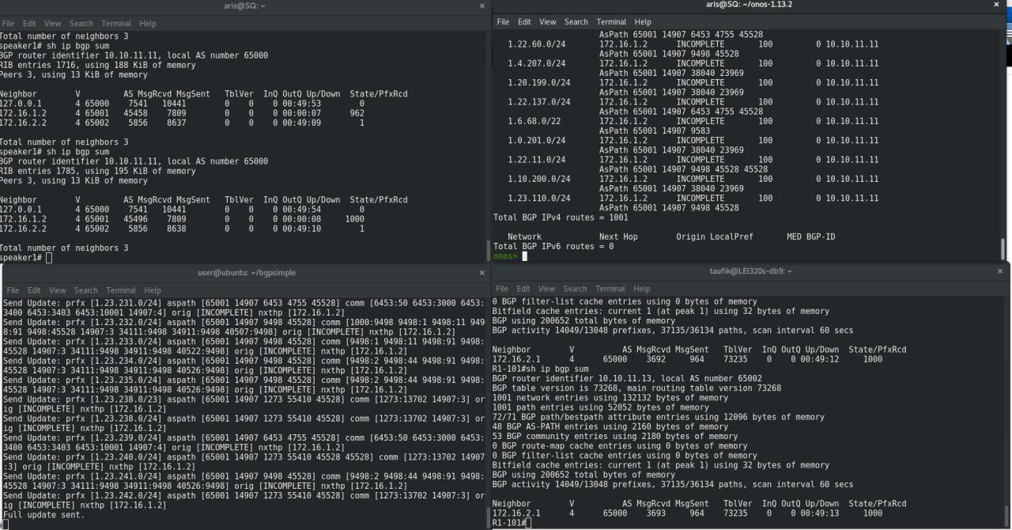 “sudo ./bgp_simple.pl -myas 65001 -myip 172.16.1.2 -peerip 172.16.1.1 -peeras 65000 -p /home/user/myroutes -m 1000 -v -keepalive 5 -holdtime 20”

- result 1000 routes :

3. Push/inject 10000 routes prefix :

- command 10000 routes :

“sudo ./bgp_simple.pl -myas 65001 -myip 172.16.1.2 -peerip 172.16.1.1 -peeras 65000 -p /home/user/myroutes -m 10000 -v -keepalive 5 -holdtime 20”

- result 10000 routes :

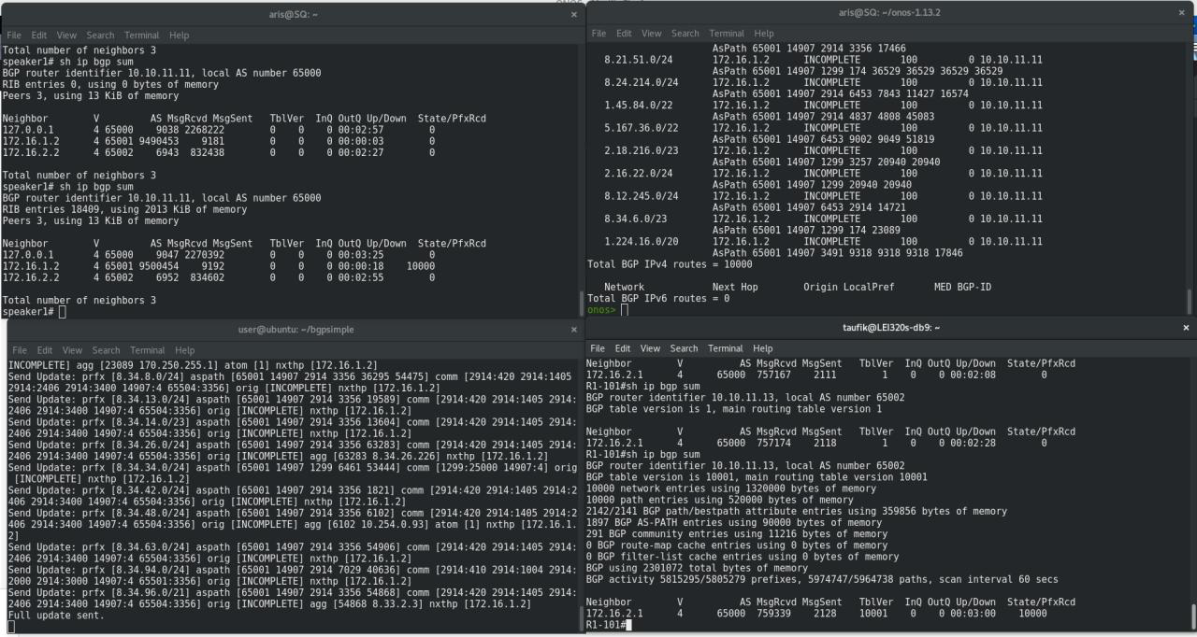

4. Push/inject 20000 routes prefix :

- command :

“sudo ./bgp_simple.pl -myas 65001 -myip 172.16.1.2 -peerip 172.16.1.1 -peeras 65000 -p /home/user/myroutes -m 20000 -v -keepalive 5 -holdtime 20”

- result 20000 routes :

